**Determining conformity assessment route for medical devices**

This SWI is based upon EUMDR 2017/745 article 52, conformity assessment procedures. Follow the chart below to determine the conformity assessment route, and the requirements each annex requires.

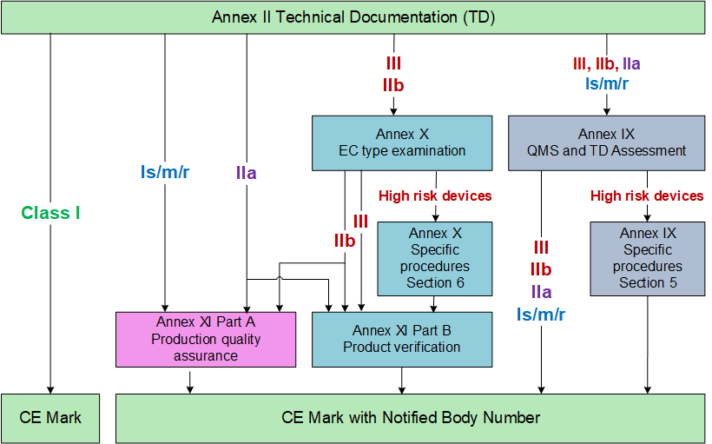

The Class of device and the Annex chosen must be recorded in the technical file.

**Authorisation to train others and to modify SWI.**

|  |  |  |  |  |  |
| --- | --- | --- | --- | --- | --- |
| **Who is authorised to train others (add to training record)** | | | **Authorised to modify SWI (add to training record)** | | |
| **Who is authorised to train** | **Authorised by** | **Date authorised** | **Who is authorised to modify** | **Authorised by** | **Date authorised** |
| GJGD | GJGD | 2/6/16 | GJGD | GJGD | 2/6/16 |
|  |  |  |  |  |  |

**Training for minor changes to SWI. Training for major changes to SWI to be recorded on Training Record SSI-QF-6B.**

|  |  |  |  |  |  |  |  |
| --- | --- | --- | --- | --- | --- | --- | --- |
| **Initial training** | | **Training on document. Mark date of training under the issue number of document you are trained on.** | | | | | |
| **Trainee** | **Trainer** | **1** | **2** | **3** | **4** | **5** | **6** |
| GJGD | GJGD | 2/6/16 | 02/05/23 |  |  |  |  |